Town of Hartford

Selectmen’s Meeting

Approved Minutes

July 6, 2023

7PM@ Hartford Town Hall & via Zoom

Present in person: Selectmen Cathy Lowe, Lee Holman, Susan Goulet, Town Clerk Lianne Bedard, Constable Steven Elsman, CEO Scott Mills, CEBE representative Claire McGlinchey, residents Douglas Marsters, Daniel Brissette, Jessica Brooks, Dianne Irving, David Bowen, Jeff Beaulieu, David Stiles, Sherri Stiles, Albert Borzelli, Paul Butler, Rebecca Elsman, Joseph Dobbins, Ken Violette, David Phair, Kathleen Theriault, David Theriault, Cynthia Violette, Daniel Riley, Claire Riley, Heather Marsters, Richard Farrar, Leslie Boness, Aaron Harvey, and others.

Present via Zoom: residents Robin, Jim Brooks, Richard Dyer, Lwind, Chad Casey, Polly Chasse, Lennie Eichman, Mark Gianelli, Ray, Thomas Hamilton, Lee Fernald, Rosemond Warren, Mary Cousins, Natasha Cote, and Nanci Weed.

I Cathy called the meeting to order at 7:02pm.

1. Elect Chairman of the Board for 2023-2024: Cathy nominated Susan Goulet as Chairman. Lee nominated Cathy as Chairman. Cathy declined the nomination. All in favor for Susan as Chairman: Yes=2 Abstained=1.

Susan explained that Roberts Rules of order would be used for meetings along with the participation policy procedures, all comments are to be directed to the Board, everyone must be respectful, one topic at a time, stand and identify yourself when speaking, and we want to hear what everyone has to say.

II Susan motioned to approve the minutes of the June 15, 2023 Selectmen’s Meeting. Cathy second. All in favor=3.

III. Susan motioned to approve Warrant 25 & 26 and Payroll Warrants June 21, 2023, June 28, 2023 & July 5, 2023. Cathy second. All in favor=3.

IV Reports

1. RSU 10 Report: The Board reviewed the results of the budget referendum which was passed on June 13, 2023.

2. Road Report: The Board reviewed the road report (attached) and thanked the road crew for the quick repair of damage from the recent rain storm.

a. Road Contracts 2023-2024: Tabled.

b. Berry Road complaint: The Board reviewed a complaint of vehicle damage (bent rims) from the slightly crumbled edge of Berry Road. No action was taken.

c. Darrington Road complaint/Riley: The Board reviewed the complaint requesting summer road maintenance of the further end of Darrington Road. The Road Commissioner has plans to do some repair on the road this summer.

Discussion: if road was maintained the plowing may have been approved at town meeting, there is damage from the rain storm, road has been closed to plowing for 50 years, the Riley’s owned the house at the end for 31 years and was never concerned with the lack of plowing but now they are older and plan to live there full time beginning this winter, the Riley’s have never denied anyone access through their property for recreational purposes, road is not crowned and road keeps washing out.

d. Samson complaint: No action.

e. BRIC Grants: Jeff Sterns is working on a grant for the Goding Road culvert issue. Tabled for research of how to prove that the town is impoverished.

3. Constable Report: The Board reviewed the report (attached).

4. CEO Report: The Board reviewed the report (attached).

a. Junkyard Violations: Harlow junkyard issue was tabled to the fact the inspection has not been completed on the two lots. Letters were sent to two property owners in town due to junkyard complaints.

Discussion: The town has not acted on expired junkyard permits for 21 years and the loss of revenue is significant and one person who says they are a hobbyist is not true since it is junk, Main St. has junk in the road, CEO is not enforcing the law, junk is at the salt shed area, people are getting special treatment, if people running the town do not comply then how do they make others comply, trying to make town better, written complaints are required on the forms at the town office and on the website, and CEO cannot inspect properties without official complaints.

b. LD 2003: The town has until July 1, 2024 to enact an ordinance or the town will have to abide by the new law which states up to three homes can be placed on three acre lots and landowners cannot divide the lots. The homes must have appropriate septic systems.

5. ACO Report: None.

6. Planning Board Report: None.

7. Ordinance Committee: None.

a. Ordinance List 2023-24: Discussion: no spray, property maintenance standards, junkyard, health and safety, vermins, nuisances. Tabled for LD2003 research

8. Fire Warden Report: None. Susan requested that reports be submitted monthly.

9. Treasurer Report

a. FEMA reserve use for road expense overage: Susan motioned to use the balance of the FEMA reserve account for summer road over expenditures. Cathy second. All in favor=3.

Lee motioned to use a portion of the summer roads reserve account for summer road over expenditures. Susan second. All in favor=3.

b. Salt Shed savings use for salt shed door repair: Lee motioned to use a portion of the salt shed savings account for the salt shed door repairs. Susan second. All in favor=3.

c. Legal reserve use for overage: Susan motioned to use the legal reserve account for legal over expenditures. Cathy second. All in favor=3.

d. Disbursement for Payroll: Lee motioned to approve the disbursement policy for payroll with option B. Cathy second. All in favor=3.

e. Disbursement for State Fees: Lee motioned to approve the disbursement policy for state fees with option B. Susan second. All in favor=3.

10. Cemetery Committee Report: It was reported that a workshop was held on June 29, 2023 at Thompson Oakes Cemetery with 4 members and 2 volunteers. 15 stones were straightened and 20 stones were cleaned. A volunteer is waiting for a landowner agreement so that he may cut trees at the Hartford Center Cemetery.

V Calendar Reminders

a. Planning Board Meeting July 10 2023 7pm

b. Ordinance Committee July 19, 2023 7pm

c. Waste Committee meeting?

VI Unfinished Business:

1. Cemetery Inspections: Inspections were completed and the Board suggested looking for volunteers to help clear trees from cemeteries that have not been mowed to the borders over the last few years.

2. ATV’s on town roads: Discussion: Civil issue if accidents occur, ATV clubs can receive grants from the state, no liability to the town, working with Sumner ATV club, would be good for the elderly or disabled to be able to get to trails and enjoy the forest areas, plan to open Stetson to Labrador Pond Road where Sumner is ok with an ATV bridge to be placed, the ATV’s will not be gathering at the town beach, right now people have to trailer ATV’s to get to trails, the roads would be open from trailhead to trailhead, not for back and forth traffic to everyone only residents on the road, intend to join Sumner ATV club for now until we can establish our own club, a Hartford trail master will deal with any issues, Sumner has a few complaints but is going very well, have to mark routes with signs, state has an obligation to monitor and deal with complaints, have to follow rules, how will we feel when someone is killed, Rumford received $24,000.00 from the State, the more trails the more money we receive from grants, roads do not count as trail system, clubs work with landowners and have to get permission from them, have to follow State laws, discontinued roads with public access allow ATV’s, should be vote of town, signs are required, no ATV access signs, green directional signs, clubs would purchase signs, was there a committee or not, and committee members were not property appointed.

Susan motioned to propose to end of current ATV season (end of October or beginning of November) to open all roads to ATV’s from trailhead to trailhead then will review the issue to see if it will continue. Cathy second. All in favor=3.

3. Town office damage repair: Susan motioned accept the estimate and to fix building as appropriate to be paid by the insurance company of the insured. Cathy second. All in favor=3. Contract was signed by the Board and the Contractor. Internet may have to be installed at the town hall in order to do business as usual.

VII Open Session:

1. CEBE grant: Claire is ready to submit a grant application for heat pumps for the town office and the town hall and solar panels for the town hall roof. The estimate was over the $50,000.00 limit. We could request an adjusted estimate with fewer panels. Panels have a warranty for 25 years. Many last for 35-40 years and disposal falls on the installer. The solar panel provider included in his estimate snow guides for the roof.

Susan motioned to accept the grant application for heat pumps and solar panels to include as many solar panels as possible under the $50,000.00 limit. Lee second. All in favor=3.

VIII New Business:

1. Bulky Waste Collection/Wood not collected: Discussion: Many residents did not have their wood collected during the latest bulky waste collection. The Solid Waste Committee had suggested that the town not collect any wood or construction material. The Board sent a letter to Archie’s requesting that no Commercial debris or large amounts of wood, etc. be collected. There was a misunderstanding since the letter was not specific. Residents are allowed to take bulky waste to Archie’s in Mexico or MWAC in Auburn. A roll off for wood would cost approximately $910.00. Out of towners dropped items in Hartford, we should find another solution for bulky items, could place roll off near town office for residents to bring wood for one day, and we haven’t received the invoice for the current bulky pickup yet.

Susan motioned to recommend that our community take their wood debris to MWAC or a facility that would accept it. Lee second. Susan withdrew her motion. Lee second. Tabled.

2. Catering application/Rita’s Catering: Lee motioned to approve the catering application for Rita’s Catering. Susan second. All in favor=3.

3. Use of Town Property to store private property/Borzelli: The tractor trailer located at the entrance to the RR Bed belongs to McNeil Farms and is used to store mulch hay for town road repair. A resident suggested moving the trailer off town property. Complaints should be directed to the town office.

IX Appointments/Resignation:

Susan motioned to appoint Keith Vashaw to the Cemetery Committee. Cathy second. All in favor=3.

Susan motioned to appoint Walter Thomas to the Cemetery Committee. Cathy second. All in favor=3.

Susan motioned to appoint Kathleen Theriault to the Cemetery Committee. Cathy second. All in favor=3.

Susan motioned to appoint David Theriault to the Cemetery Committee. Cathy second. All in favor=3.

X Training: None.

XI Review Correspondence: The Board reviewed correspondence.

XII Meeting adjourned at 10:30pm.

Minutes approved by:

___________________________________ _______________

Cathy Lowe Date

___________________________________ _______________

Lee Holman Date

____________________________________ _______________

Susan Goulet Date

Town of Hartford

Road Report

July 6, 2023

The roads damaged by the June 29th flash flood were repaired that night and the next day.

The road crew has begun cutting the beach parking area and the wood has been given to the Hartford wood bank.

We will be getting started on road work shortly.

A complaint was received from the Riley’s on Darrington Road and we do plan to do some work on the road but we have always done very limited maintenance on the road to make it passable.

Submitted by,

Bim McNeil

Road Commissioner

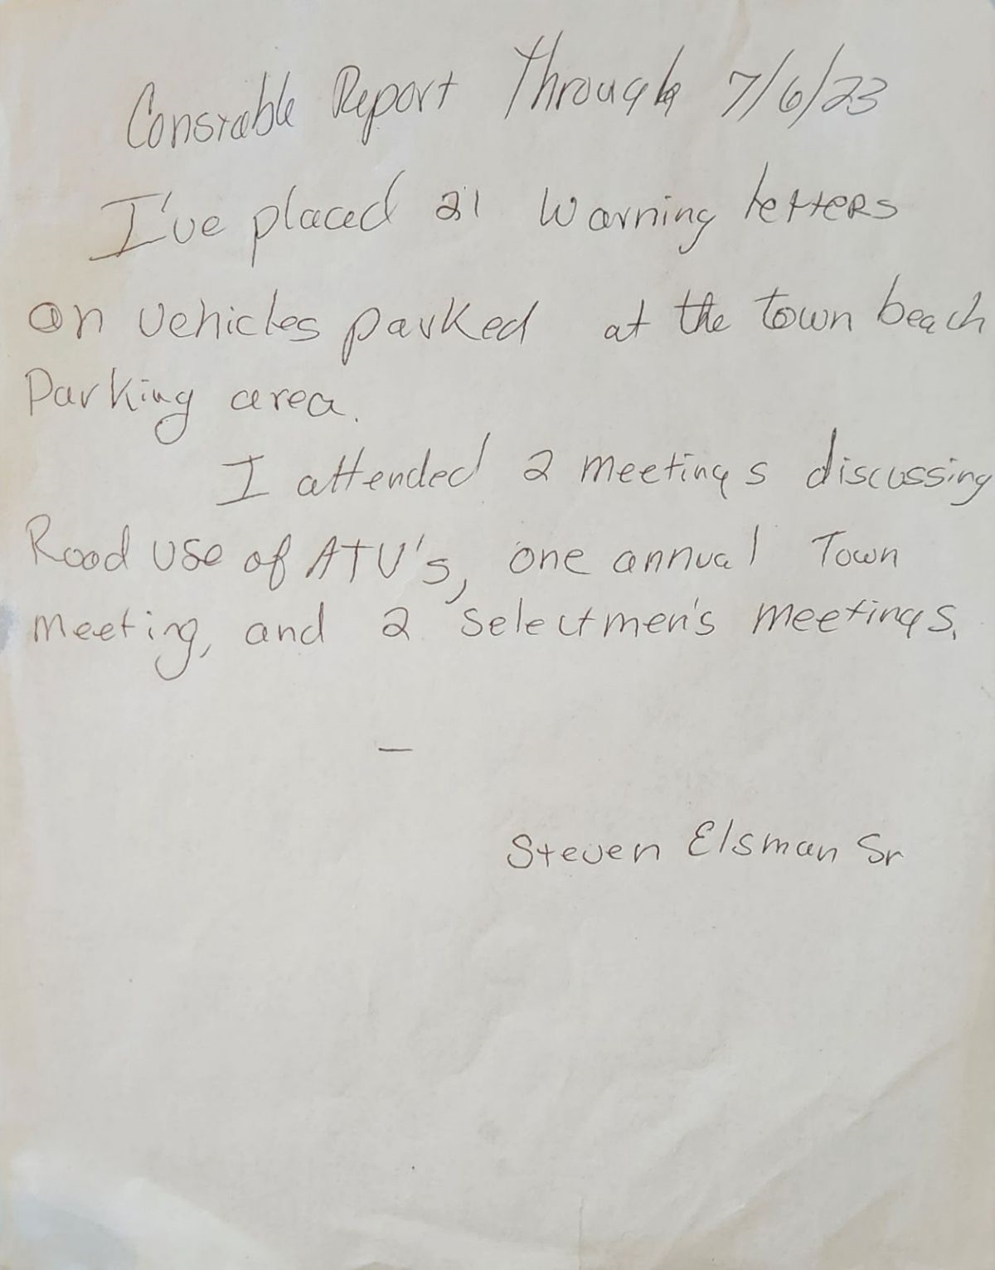

Report from the Code Enforcement Officer

Date: June 30th, 2023

Year to Date Report:

Year to Date Building Permits Issued: 12 - last yr. 15

Year to Date Plumbing Permits Issued: 3 - last yr. 13

Complaints:

Junkyard Law violation Berry Road - Notice was sent to property owner to apply for a Junkyard Permit or remove vehicles.

Junkyard Law violation Camp Road - Notice was sent to property owner to apply for a Junkyard Permit or remove vehicles.

Tree Cutting in SLZ Little Bear Lane – Notice was sent to land owner to contact me for an inspection.

Inspections:

Jones Drive – SLZ construction inspection.

Other:

None

Respectfully Submitted

G. Scott Mills

CEO/LPI Hartford, Me

Town of Hartford, Maine Plumbing Permit Log 2023

7/22/2023

Date Last Name First Name Location Purpose 2023-P-04

2/3/2023 2023-P-01 Salisbury Debbie R12-38.9, 9 Adam Lane Internal Plumbing 2023-P-05

4/17/2023 2023-P-02 Hyland Interior DesigR4-15, 233 Gurney Hill Rd New Septic 2023-P-06

4/27/2023 2023-P-03 Goodwin Ira U10-10, Bear Pond Rd Internal Plumbing 2023-P-07

